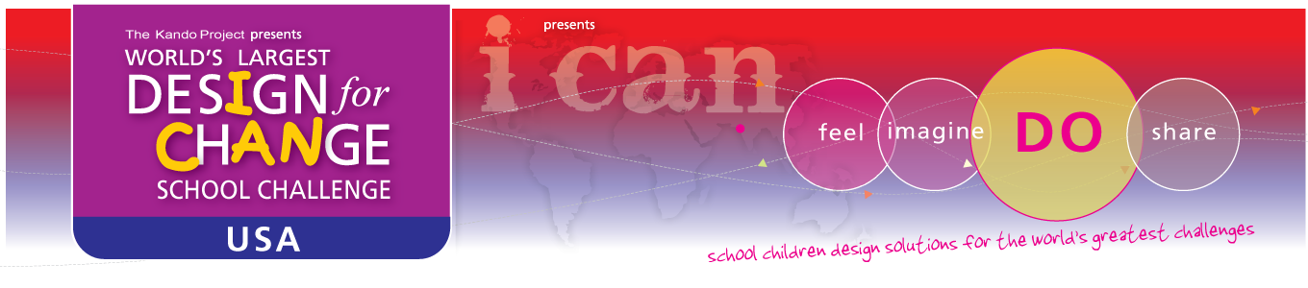**Submission**

**Process**

* As the mentor/teacher for your class project, you will be required to submit your project using the Design for Change online platform which can be found on the website.

**Deadline**

* The last day to submit your entry is Saturday March 30th 2013.

**Structure**

* We request that your submission be broken up into the four Design for Change stages:

*Feel, Imagine, Do, Share*

**Format and Standards**

* We are able to accept your submission in the following formats and are happy to accommodate others upon request:

*PowerPoint, Video, PDF, Word Document*

**Important Information**

* Be sure to document your project at every stage, this footage/documentation will be vital when constructing your final presentation
* Please remember, the goal of your presentation is to narrate the story of your class project as you ventured through each stage of the curriculum e.g., highlight key events and struggles

If you have any difficulty with the submission platform, please notify us at [info@designforchange.us](mailto:info@designforchange.us)



**Judging**

All entries will be judged by industry leaders including faculty from Harvard and Stanford University. Each entry will be assigned a point value out of 20 and will be evaluated based on the following 5 categories:

|  |  |  |  |  |  |
| --- | --- | --- | --- | --- | --- |
| **Design for Change - USA** | | | | |  |
| **Judging Rubric** | | | | |  |
| ***Scoring*** | ***1 Point*** | ***2 Points*** | ***3 Points*** | ***4 Points*** | ***Your Score*** |
| **Categories** | **Novice**  **Change Agents** | **Intermediate**  **Change Agents** | **Advanced**  **Change Agents** | **Master**  **Change Agents** |  |
| **Boldness of idea - looking at an existing problem with a fresh perspective** | Commonly done in other places, but effective and helpful | Done in only a few other places | Not done before-but looks like common sense | Not done before-and considered revolutionary |  |
| **Number of people impacted** | Immediate community | Adjacent neighborhoods | My city | My state |  |
| **Potential for long lasting change** | None | Good | Great | Guaranteed |  |
| **How easy is the idea to replicate** | One time project | Can be done elsewhere with minor changes | Works everywhere without changes | Works everywhere without changes and will spread like a virus through existing networks |  |
| **How green is the idea** | Neutral to the environment | Has a positive impact | Will clean up the environment in a major way | Positive impact to the environment and will change the lives of people |  |

If you have any questions regarding the evaluation process, please notify us at [info@designforchange.us](mailto:info@designforchange.us)